This is to certify that

Selwyns Travel

Was awarded a six star Benchmark rating by BUSK UK for meeting legal and safety compliance background checks.

License number: BE0045
Membership expires: 28 February 2018

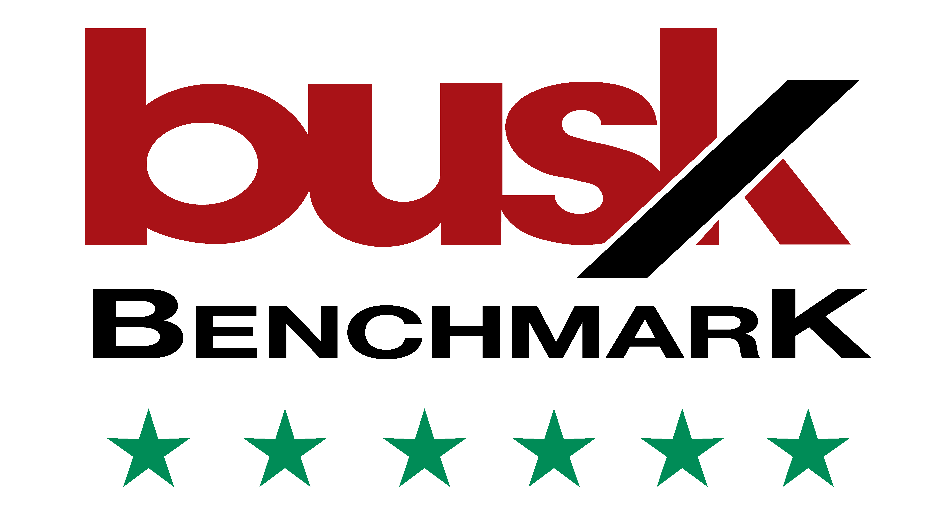

Background checks are carried out independently by:

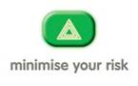

IVTAServices
Independent Vehicle Test Audit Services

